

1/6/2014

Re: NPA 274 to Overlay NPA 920 (Wisconsin) – Mandatory Dialing begins 1/25/14

Dear Customer,

In Supplemental Final Decision of Docket 5-TN-106, dated November 15, 2010, the
Public Service Commission of Wisconsin ordered the previously approved 920-274 NPA
overlay to be postponed due to the change in the forecasted exhaust of the 920 NPA to
2Q2014. The 920 NPA generally covers the north eastern portion of the state and serves
communities such as Appleton, Beaver Dam, Berlin, Fond du Lac, Fort Atkinson, Green
Bay, Manitowoc, Oshkosh, Ripon, Sheboygan, Sturgeon Bay and Watertown. The new
274 NPA will serve the same geographic area currently served by the existing 920 NPA.
This Planning Letter reflects new implementation interval dates.

Implementation of Relief Plan
Implementation of the overlay of the 274 NPA is as follows:
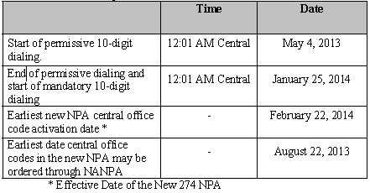

PHASE I
Permissive Dialing Date – Began May 4, 2013. This allows for local dialing with either 7 digit or 10 digit. Any necessary updates or changes must be made during this time period prior to the Mandatory Dialing Date. During the permissive dialing period, subscribers may dial local calls within the overlay
area on either a 7-digit or 10-digit basis, but will be encouraged to dial 10-digits. After
the permissive period ends, all calls must be dialed using 10-digits.

PHASE II
Mandatory 10 Digit Dialing Date Begins January 25, 2014 - All callers must dial local calls with 10 digits. If you inadvertently dial 7 digits, your call will not be completed and a recording will prompt you to hang up and dial again.

Dialing Plan
Coincident with the introduction of mandatory 10-digit dialing, the dialing plan for the
920 and 274 NPAs will be as follows:
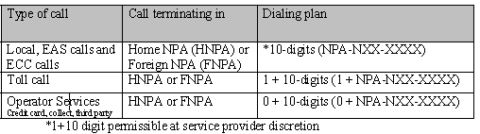

To prepare for this overlay, please note the following:

- Notify your clients, vendors, and others, domestic and international of your new area code.
- Inform employees, customers, and co-workers
- Changes in telephone equipment should be directed to the equipment vendor.
- Utilize the applicable test number to make sure your equipment recognizes the new area code.
- Update all correspondence, such as stationery, business cards, checks, brochures, promotional items, internet web pages, catalogs, directory listings
- Reprogram features such as Auto-Dialing, Speed dialing, and Call Forwarding
- Reprogram security doors and gate systems.
- Contact your service provider to update your cell phone and other wireless communications.
- Internet dial-up connection may need reprogramming or upgraded.
- Notify Alarm system providers of the new area code + telephone number so they can update their records and equipment as needed.

The area code overlay will not affect the cost of a call. Costs incurred for updating systems and revising printed materials is the responsibility of the customer. The directory listings (white pages) will be updated by the telecommunications industry. Listings appearing in other directories will be the responsibility of the customer.

If you have any additional questions, please contact your Premier Specialist or Customer Service 1-866-847-5500.

